# ***Ahsanullah University of Science & Technology***

Department of Computer Science & Engineering



**Hospital Management System**

CSE 3224

Information System Design & Software Engineering Lab

Submitted By:

Shadman Sakib 16.01.04.092

A.K.M. Sadman Ali 16.01.04.093

Tasmia Tuj Juha 16.01.04.095

Mehedi Hasan Abir 16.01.04.102

Date of Submission: **12 February, 2019**

**Contents:**

1. Sampling Decisions…………………………………………………….… 3
2. Sample Design………………………………………………………………..3

2.1) Sample Size………………….. ……………………………………… 3

2.2) Parameters of Interest………….. ………………………………..3

2.3) Sampling Technique……………………………………………….3

1. Data Collection Tools Used……….………………………………….....3
2. Questionnaire on Hospital Management System………………4

4.1) Personal Information ……………………………………………….4

4.2) Survey Questions…………………………………….………………..4

4.3) Demographic Questions…………………………………………….7

1. Data Analysis……………………...…………………………………………..8
2. Overall Findings……………………………………………………………. 28
3. Conclusion……………………………………………………………………..28

**Sampling Decisions:**

We have undertaken target-oriented method for sampling and it was solely web based. Our target research included Facebook, Messenger, WhatsApp and we used Google form to get responses.

**Sample Design:**

**1.** **Sample size**: The sample size selected for our research is 66.

**2.** **Parameters of interests:** The major parameter of interest is the subgroup of people having an experience of vising hospitals and using internet.

**3. Sampling Technique:** The sampling technique used for the research is simple random sampling technique.

**Data Collection Tool Used:**

The data collection tool used for the research is “Questionnaire”. We used it to get the primary data for the empirical research on user preference on hospital management system.

Google form was used to perform the questionnaire.

Link:

<https://docs.google.com/forms/d/1Ie-XQtCRgKpsJ_lp_AgmZBPPkTMyeFajow53Ai9xXNc/viewanalytics>

The Questionnaire attached below consists of several questions in a specific order on a form read by the respondents.

**Questionnaires on Hospital Management System:**

(We are trying to create a software for the automation of Hospital Management. We would like to know about your experiences regarding the management systems of hospitals, based on hospitals you've visited so far. You can help us by answering a few questions. Your information will remain confidential. Thank you.)

**Personal Information:**

Name: ________________________________________

Email: _________________________________________

**Inquiry for Hospital Management System:**

1) How often do you visit hospitals? *

* Once a week
* Once a month
* Once every two months
* Twice a year
* Once a year
* Almost every day (I work there)
* Other: ________________________________________

2) How is the management system of the hospitals you went to or the hospitals you worked at? *

* Efficient
* Inconvenient
* Lacks organization
* Perfectly fine
* Other: ________________________________________

3) Do the doctors regularly attend to patients at the scheduled time? *

* Yes
* No
* Sometimes

4) How long do you have to wait before getting scheduled appointment? *

* 15 mins
* 30 mins
* 1 hour
* 2 hours
* Above 2 hours
* No waiting at all

5) How do you get your reports and prescriptions? *

* Paper-based
* Internet-based

6) Do you have difficulties finding all your prescriptions and reports before seeing the doctor? *

* Yes
* No

7) Would you prefer if your reports and prescriptions were stored in digital format in a database? *

* Yes
* No

8) How long have you been using Internet? *

* less than a year
* 1-3 years
* 3-5 years
* more than 5 years
* Not at all

9) On an average how much time of the day do you spend on surfing the web? *

* less than an hour
* 1-3 hours
* 3-5 hours
* more than 5 hours

10) Do you have any experience of making doctor appointments online? *

* Yes
* No

11) If you have made an appointment online, how was your experience?

1 2 3 4 5

Terrible ○ ○ ○ ○ ○ Excellent

12) Do you think it's convenient if you can schedule appointments online and get your reports, prescriptions in an online platform? *

* Yes
* No

13) Would you like your medical history to be saved for future use? *

* Yes
* No

14) What features in a Hospital Management System will please you? *

◻ User Friendly Interface

◻ Data security and privacy policy

◻ Detailed Information about doctors' schedules

◻ Doctors' records

◻ Organized database

◻ Fast Service

15) Please tell us if you agree or disagree with each of the following statements about Hospital Management System. *

Strongly Disagree Disagree Neutral Agree Strongly Agree

Online based hospital

Management is ○ ○ ○ ○ ○

Convenient

Managing and maintaining

Up-to-date data online is ○ ○ ○ ○ ○

Much easier

Online system can lessen the

workloads and reduce time ○ ○ ○ ○ ○

for management part

16) How satisfied or dissatisfied are you with the current hospital management process?

_________________________________________________________________

17) If dissatisfied, what are some things you would change about today's hospitals?

________________________________________________________________

**Demographic information:**

Gender:

* Female
* Male

Age:

* Below 18
* 18-25
* 26-35
* 36-45
* 46-55
* 56-65
* Above 65

City of Residence:

* Dhaka
* Chittagong
* Rajshahi
* Sylhet
* Barishal
* Chandpur
* Khulna
* Other: ________________________________________

Occupation:

* Student
* Doctor
* Hospital Employee
* Teacher
* Employee of an Organization
* Businessman
* Other: ________________________________________

Monthly Income (BDT):

* No income
* Below 10,000
* 10,000-20,000
* 20,000-30,000
* 30,000-40,000
* Above 40,000

**Data Analysis:**

**Demographic information:**

1. **Gender:**

|  |  |  |
| --- | --- | --- |
| Male | Female | Total |
| 37 | 29 | 66 |

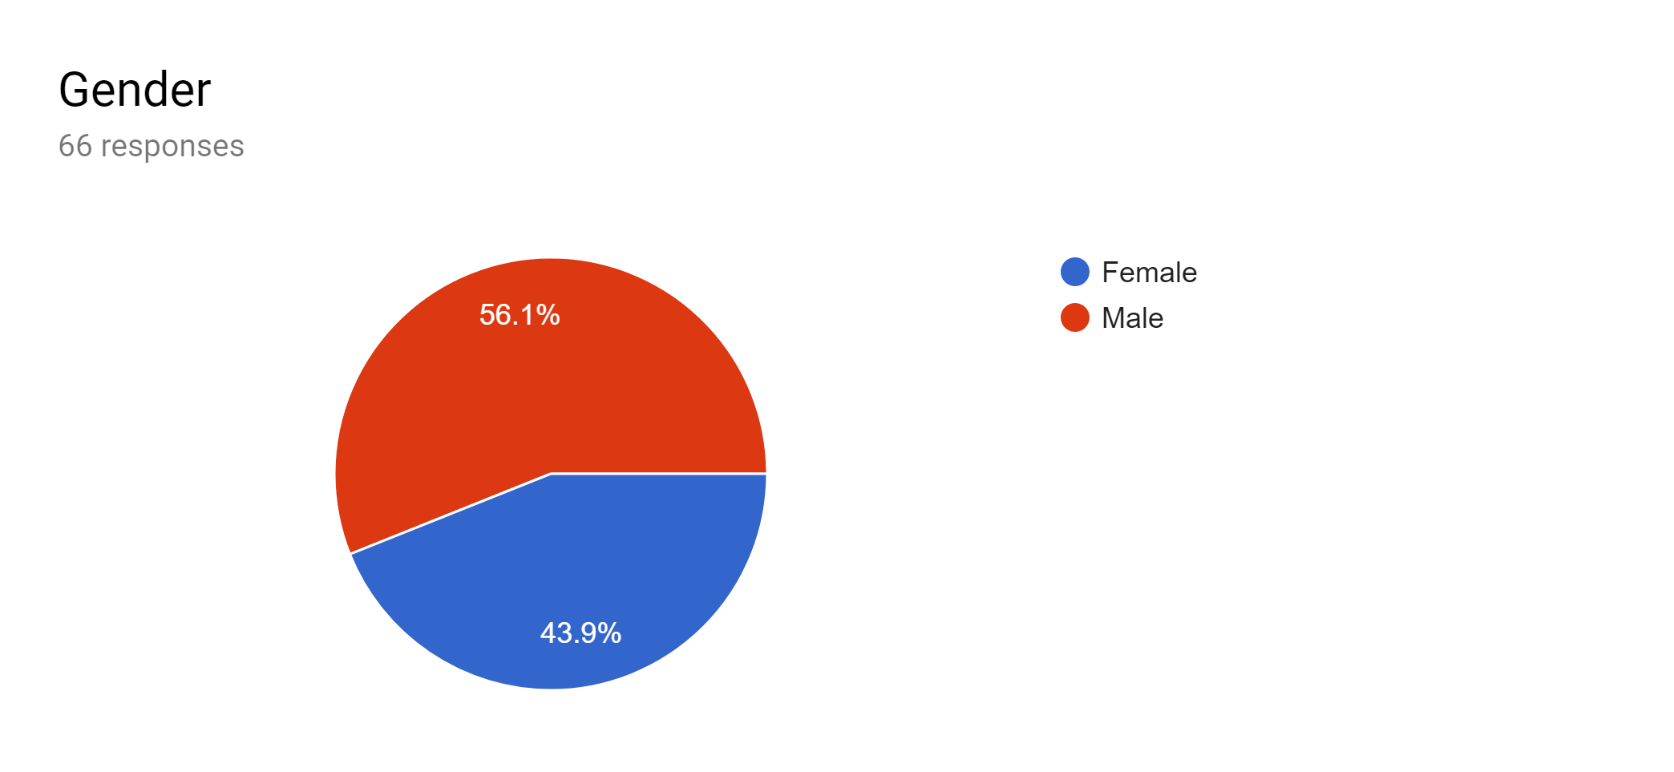

**Illustration:**

The above diagram depicts that out of the total 66 respondents, 56.1% were male and 43.9% were female. The margin between the two is not very significant since both male and female population visit hospitals.

1. **Age group:**

|  |  |  |  |
| --- | --- | --- | --- |
| 18-25 | 26-35 | 36-45 | 46-55 |
| 60 | 2 | 3 | 1 |

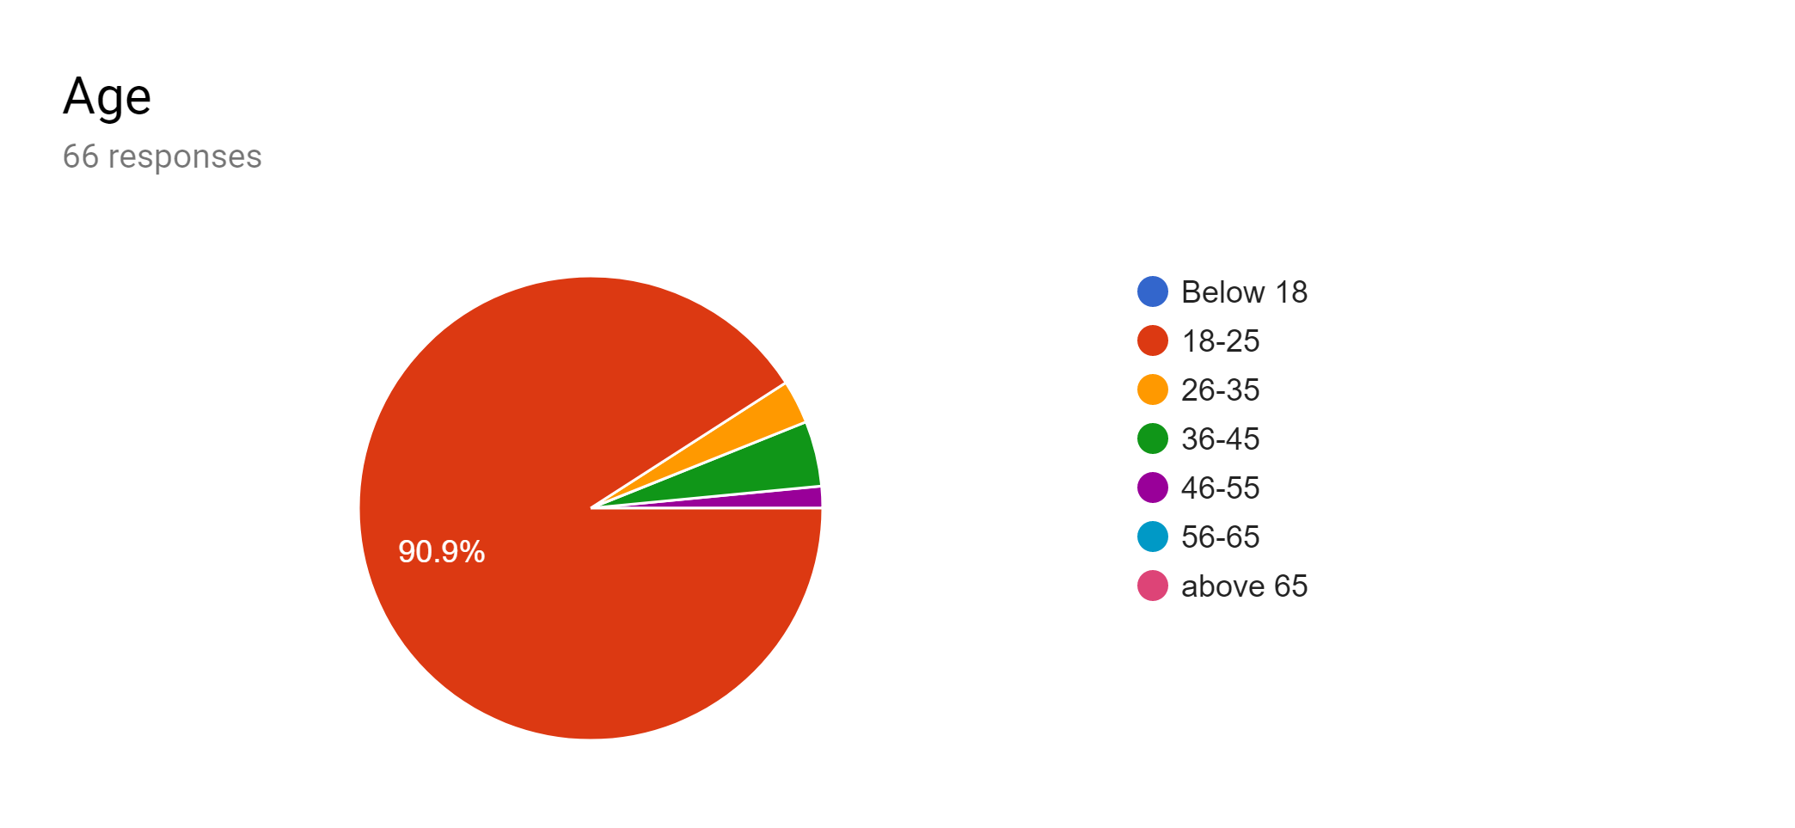

**Illustration:**

90.9% of the respondents were among 18-25 age bracket as these age group respondents use internet on regular basis. The remaining people may not use internet frequently.

Even though a large portion of older people frequently visit hospitals, they do not use internet. But young people in their family are most likely regular internet users. Thus, with the help of the young, the old people can surely benefit from an online management system.

1. **City of Residence:**

|  |  |  |  |  |  |
| --- | --- | --- | --- | --- | --- |
| Dhaka | Chittagong | Rajshahi | Sylhet | Barishal | Khulna |
| 58 | 2 | 2 | 1 | 1 | 2 |

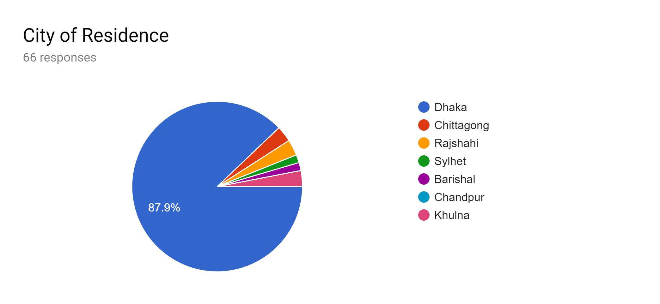

**Illustration:**

The above diagram depicts that 87.9% of the respondents were from Dhaka as its residents are more familiar with latest technology as they use internet more frequently compared to other cities. Also, the sample of people surveyed were mostly from Dhaka as we are living here.

Having said that, there were also a small portion of respondents from Chittagong, Rajshahi, Sylhet, Barishal and Khulna.

1. **Occupation:**

|  |  |  |  |  |
| --- | --- | --- | --- | --- |
| Student | Doctor | Teacher | Employee of Organization | Businessman |
| 58 | 3 | 1 | 1 | 3 |

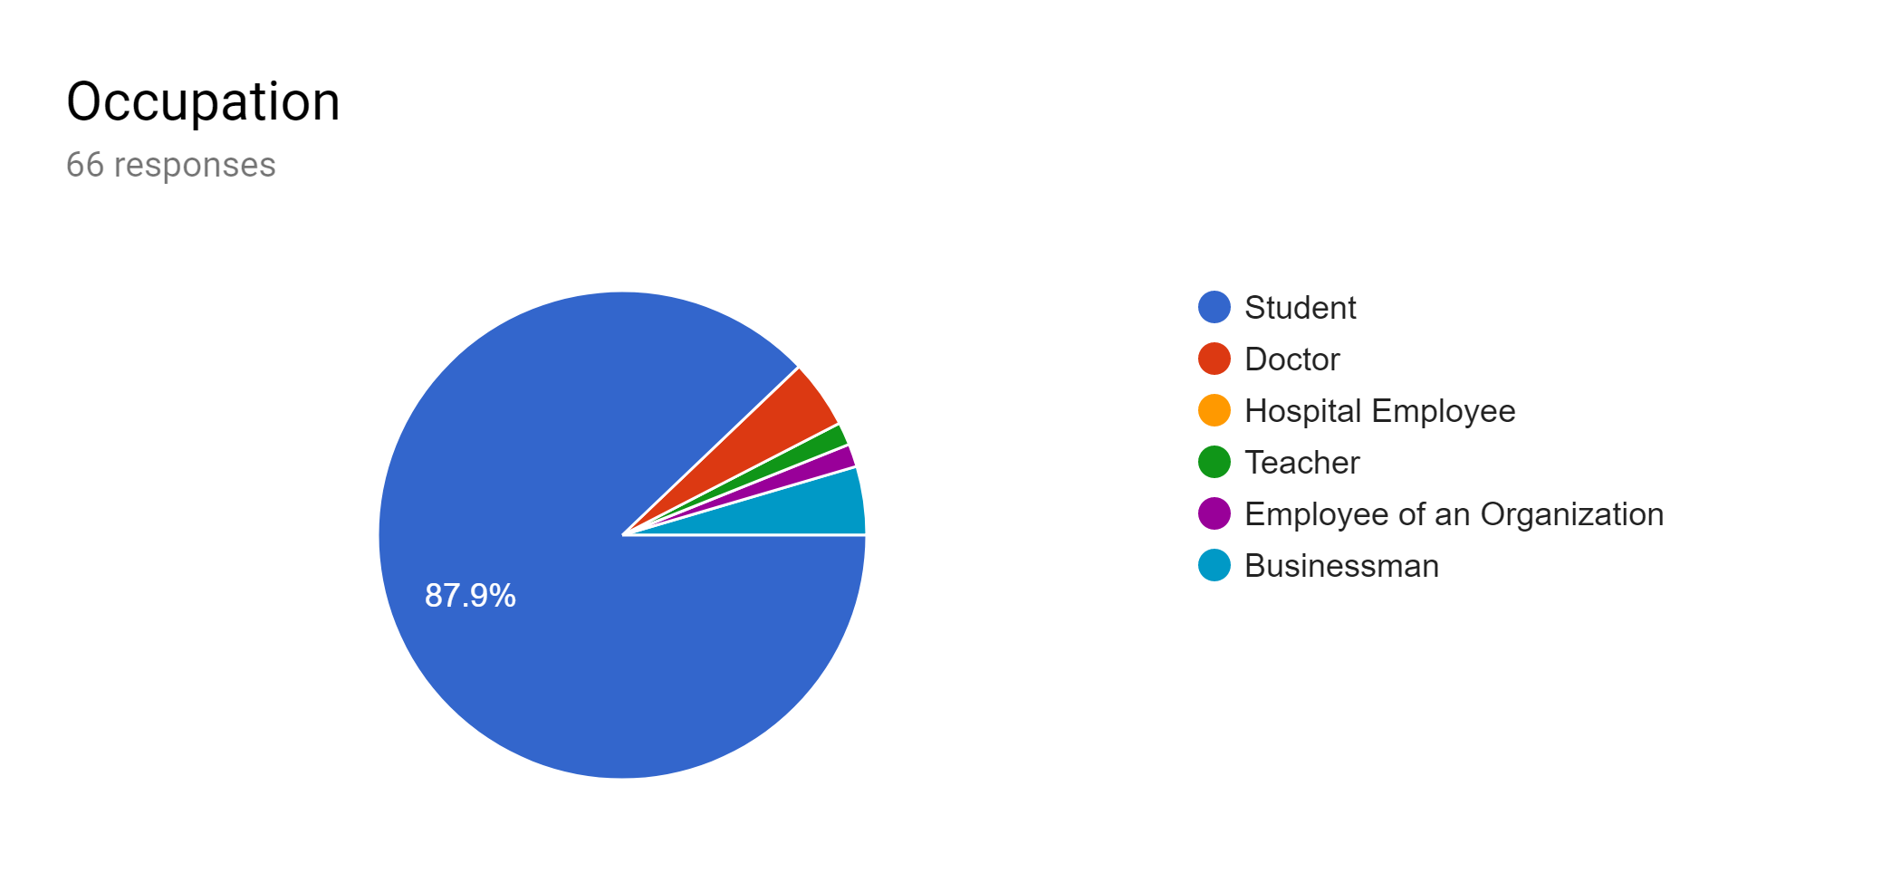

**Illustration:**

87.9% of the respondents were students as they are avid users of internet. Some portion of respondents were also doctors, teachers, businessman and employees of organizations.

1. **Monthly Income:**

|  |  |  |  |  |  |
| --- | --- | --- | --- | --- | --- |
| No Income | Below 10,000 | 10,000-20,000 | 20,000-30,000 | 30,000-40,000 | Above 40,000 |
| 36 | 12 | 7 | 1 | 5 | 4 |

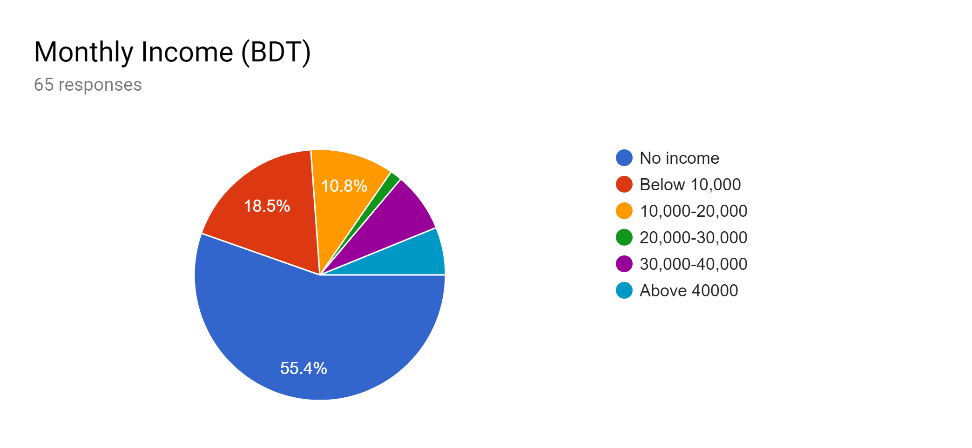

**Illustration:**

55.4% of the people have no income. It’s safe to assume that these people fall under student category. But also 18.5% people have income below 10,000 and 10.8% people have an income in the range 10,000-20,000. Finally, there are small percentages of people in the 30,000-40,000 range and above 40,000 range.

**Inquiry for Hospital Management System:**

**6)** 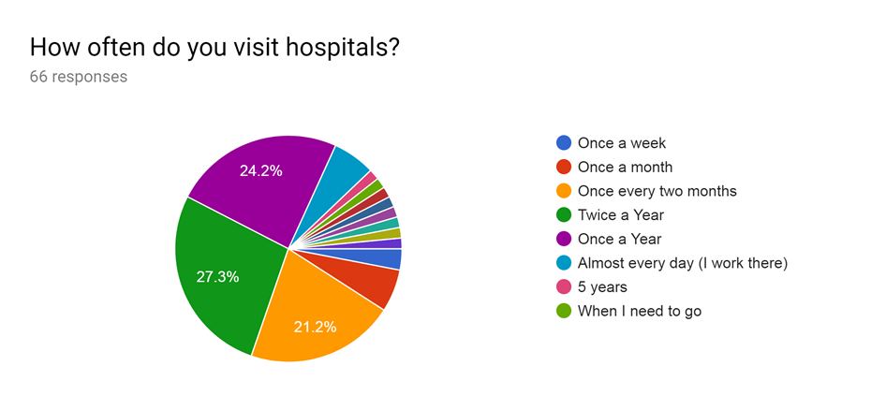

**Illustration:**

From the above chart, it is evident that frequency of hospital visits varies from person to person. It’s dependent on their age, health, occupation etc.

From a wide change of choices, we have 27.3% people who visit hospitals twice a year, 24.2% people who visit once a year. And we have 21.2% people who visit once every two months.

6.1% people visit hospitals once a month, presumably for regular check-ups. Also, 6.1% people visit hospitals on a daily basis since they work there.

**7)**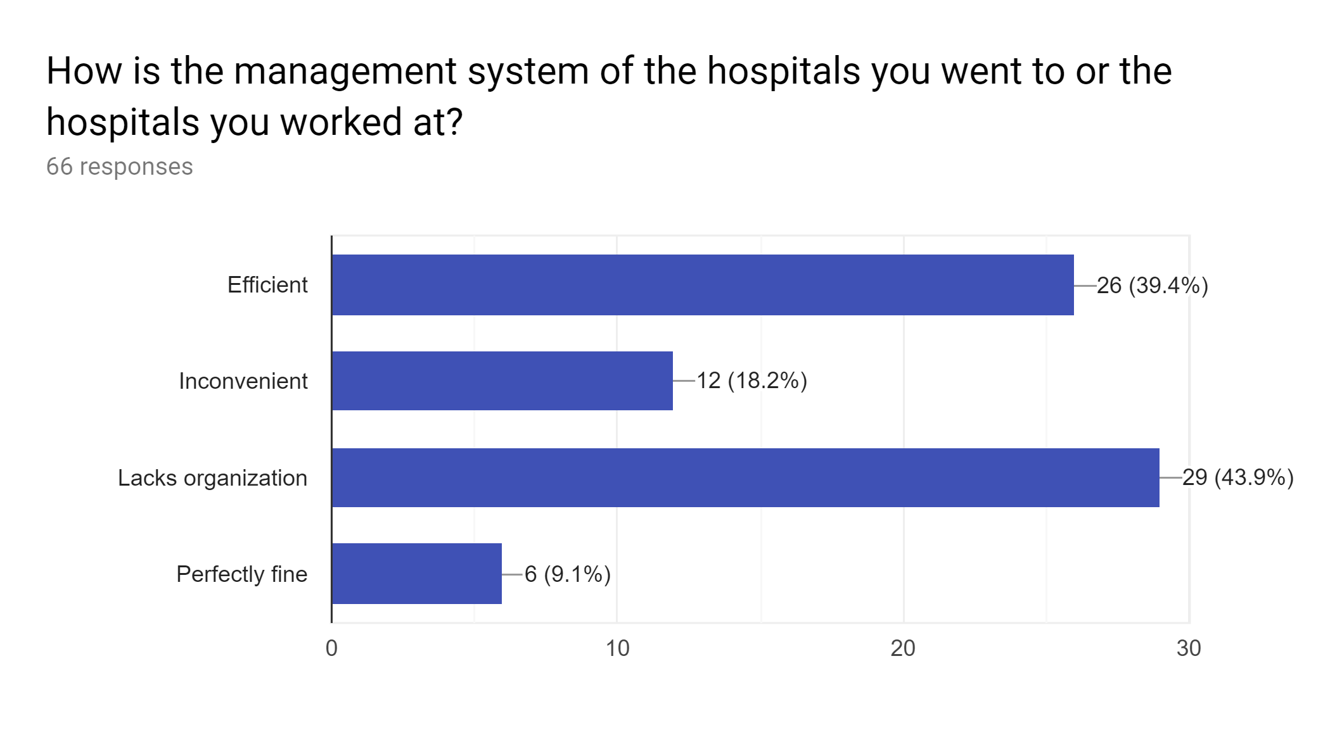

**Illustration:**

* The above diagram illustrates that maximum percentage (43.9%) of respondents believe that the hospitals they went to or worked at lack organization in management system.
* While some renowned hospitals may have efficient management system (according to 39.4% people), they are far from perfect. This statement is backed up by the fact that very small percentage (only 9.1%) of people think that the management system of hospitals they went to are perfectly fine. Furthermore, 18.2% people think the system is inconvenient for them.

Thus, there is certainly room for improvement.

**8)**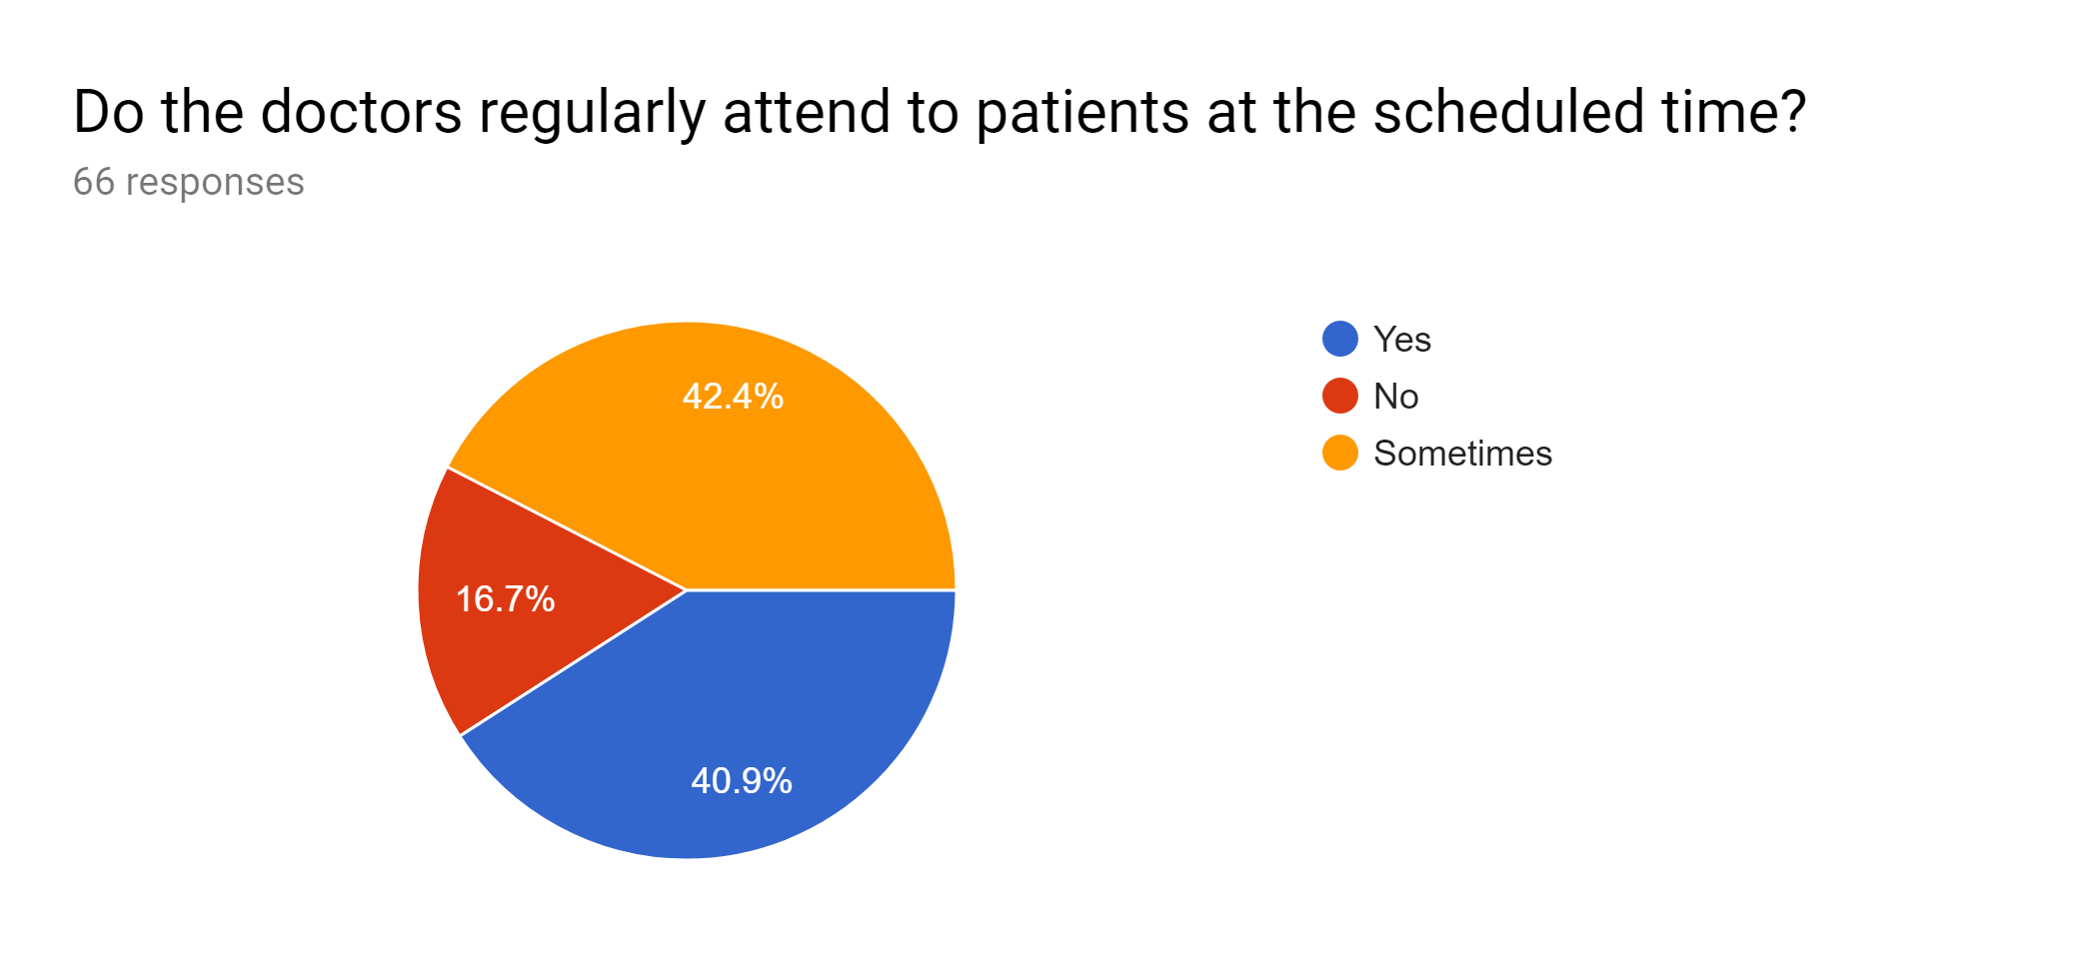

**Illustration:**

* From the above chart, we have majority of 42.4% people responding “sometimes”. This clearly indicates that patients are not regularly attended to at scheduled time. Sometimes they get attended early but sometimes they get attended to very late.
* 40.9% people have said the doctors don’t attend at scheduled time at all. This is an alarming sign and speaks volumes about the lacking of the management process.
* Only 16.7% people have responded “Yes”, which signifies the rare instances in which the appointments are always timely.

**9)**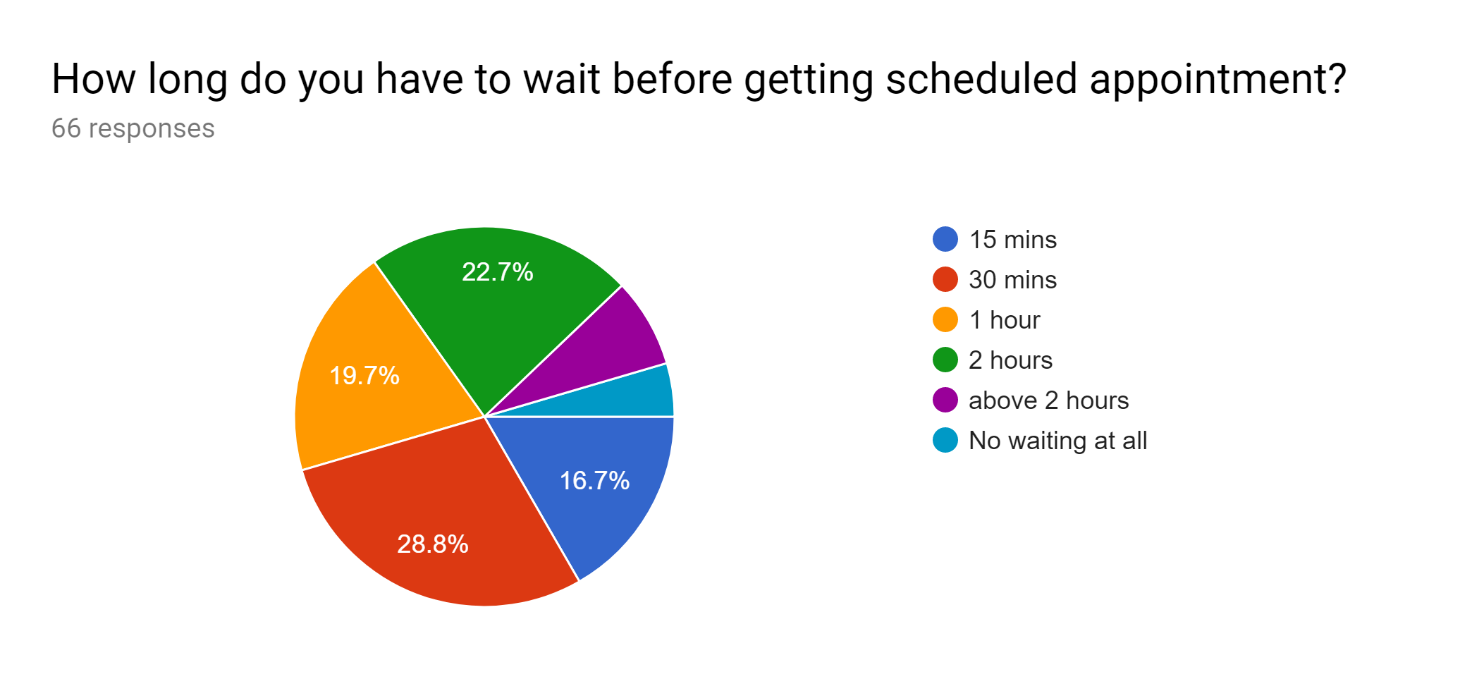

**Illustration:**

* The above diagram clearly depicts that most of the people have to wait long (30 mins-2 hours) before getting scheduled appointment.
* Spending 2 hours or even more idly sitting down cannot be good utilization of time. It hampers productivity.
* The number of people who don’t have to wait at all is negligible.

**10)**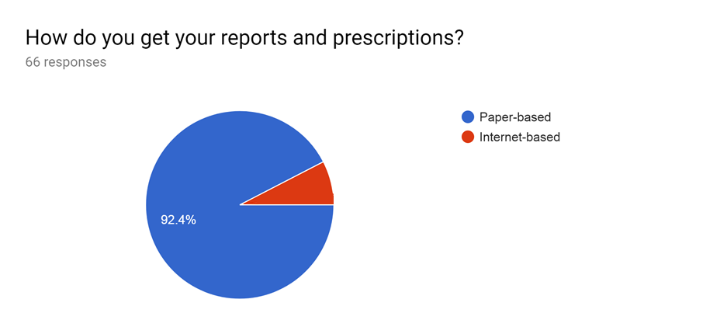

**Illustration:**

* The above diagram depicts that 92.4% of the respondents get their medical reports and prescriptions via paper-based system as there are hardly any good websites for providing medical reports and prescriptions via internet.
* The rest of the respondents are familiar with internet-based reports and prescriptions.

**11)**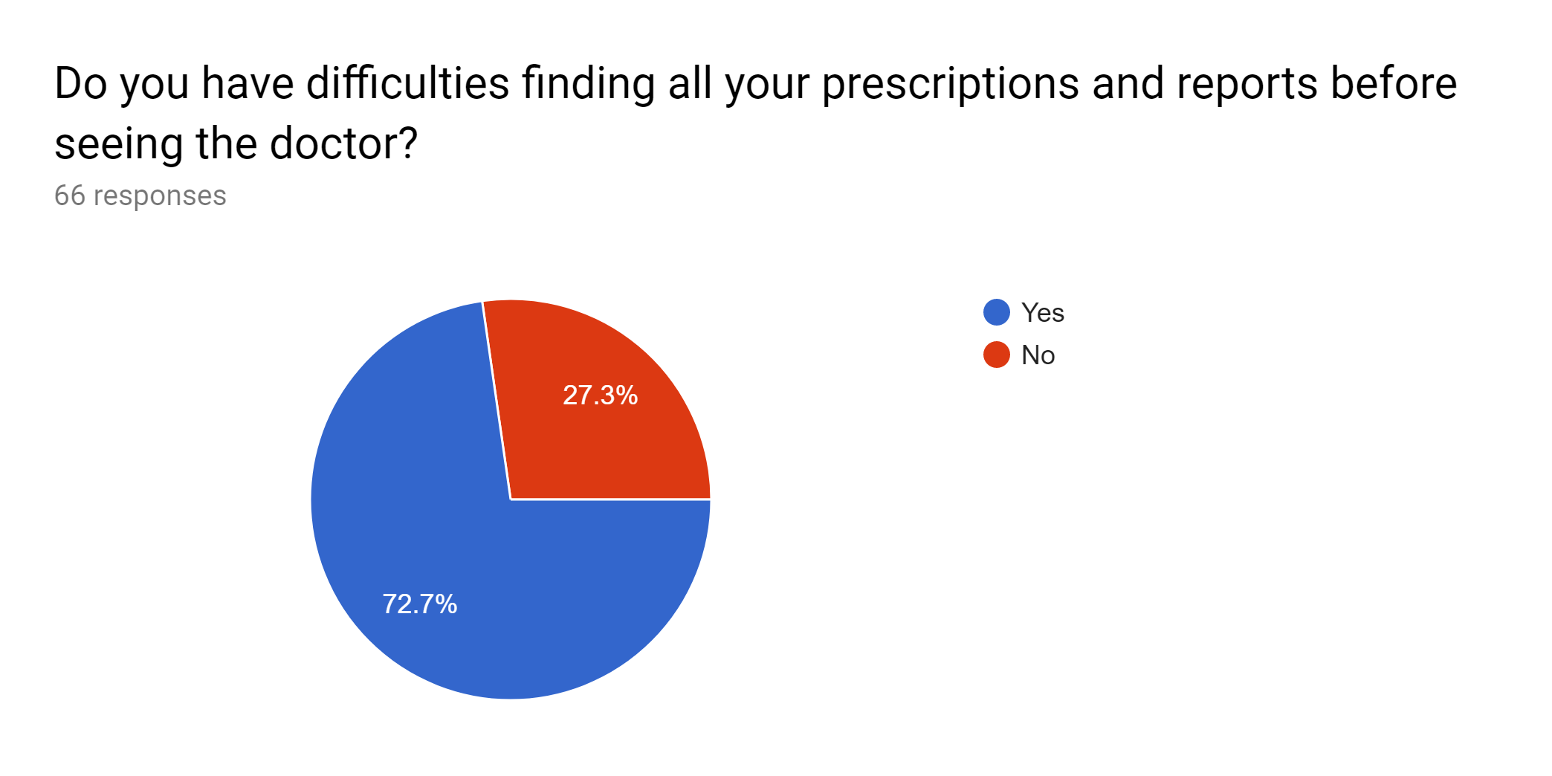

**Illustration:**

From the above diagram we can say that most of the people have difficulties finding their medical reports and prescriptions which clearly shows the drawbacks of paper-based management system in hospitals.

**12)**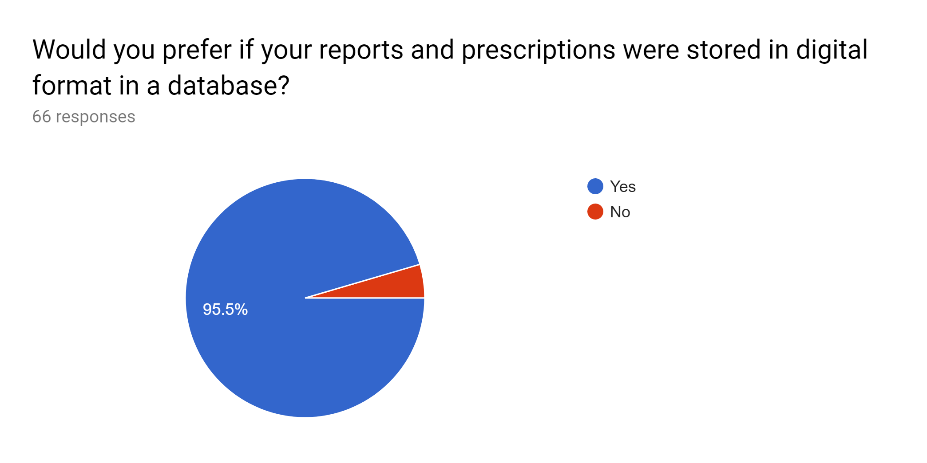

**Illustration:**

* A majority of 95.5% people would prefer their reports and prescriptions to be stored in digital format.
* A minority of 4.5% people would rather have paper-based reports and prescriptions since they are used to it. Also, they might not be well familiarized with internet. It is likely that they are unsure about the merits of an online system.

**13)**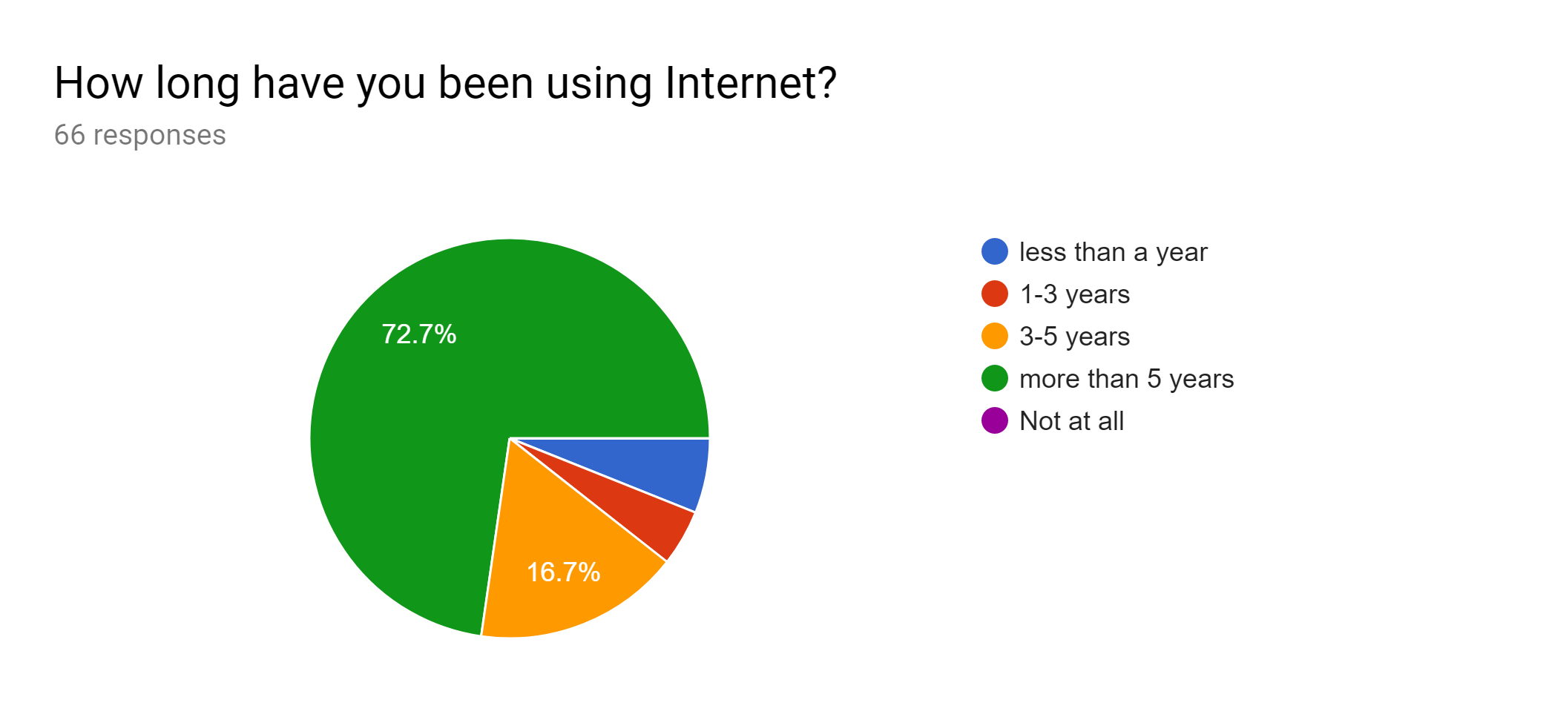

**Illustration:**

* 72.7% people have been using internet for more than 5 years. It is clear that they are avid users of internet.
* 16.7% people have not been using internet for 3-5 years.
* From the above chart, it’s safe to assume that there are hardly any people who don’t use internet.

**14)**

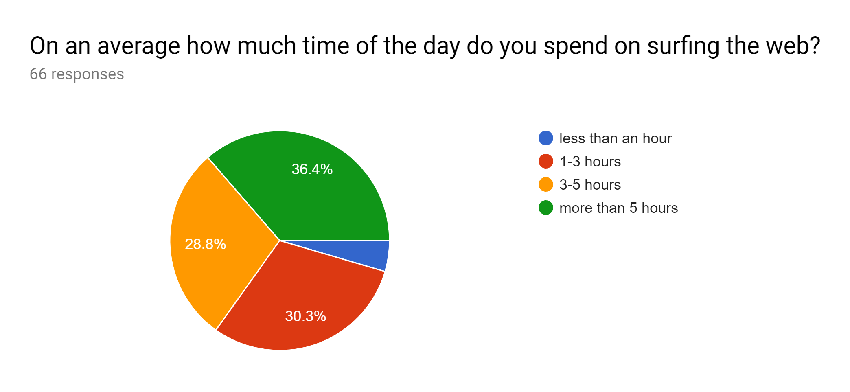

**Illustration:**

* 36.4% people use internet for more than 5 hours. So, they are always prepared to receive any new information that might become available online.
* 30.3% use internet 1-3 hours, which is also enough time to get updates daily.
* 28.8% people use internet for 3-5 hours, which is more than enough time to be acquainted with new information.
* Very small percentage (4.5%) use internet for less than an hour.

**15)**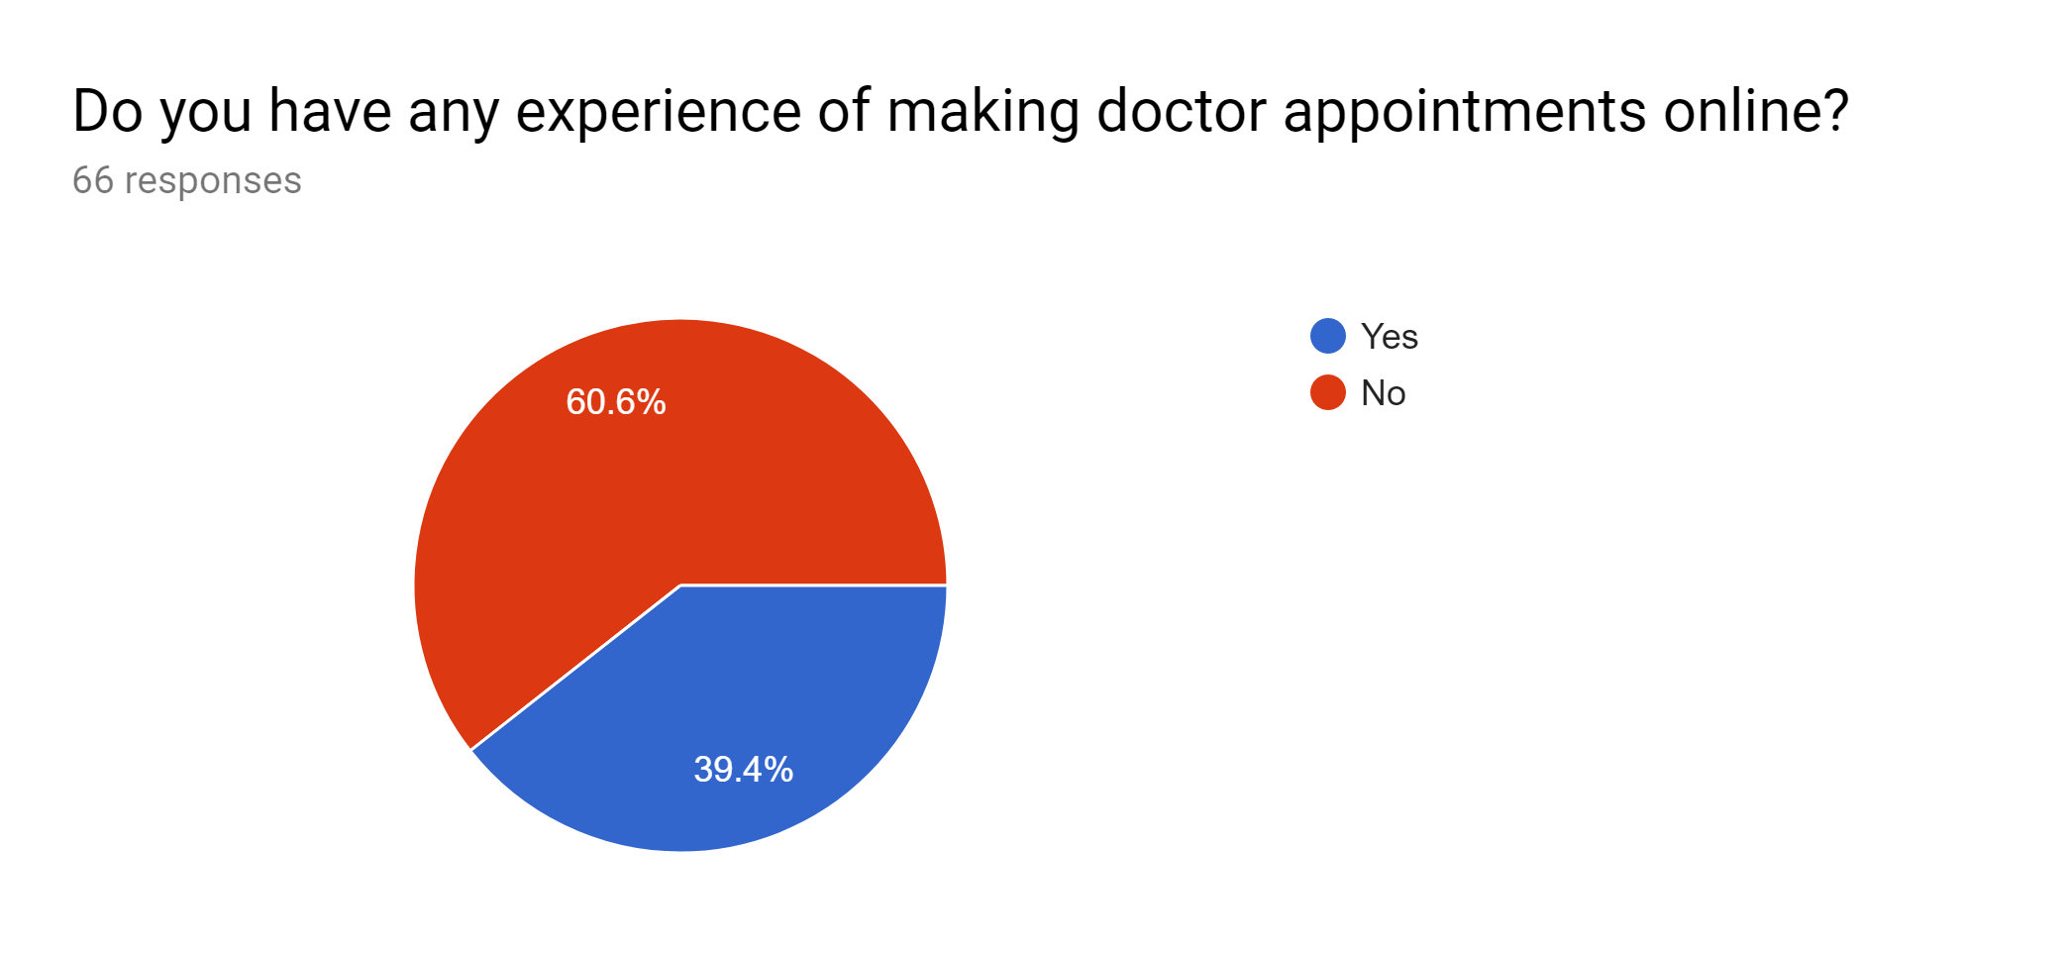

**Illustration:**

* A majority of 60.6% people have no experience of making appointments online. This is no surprise since in our country the appointments are done in person or via phone calls.
* A minority of 39.4% people do have experience of making online appointments.

**16)**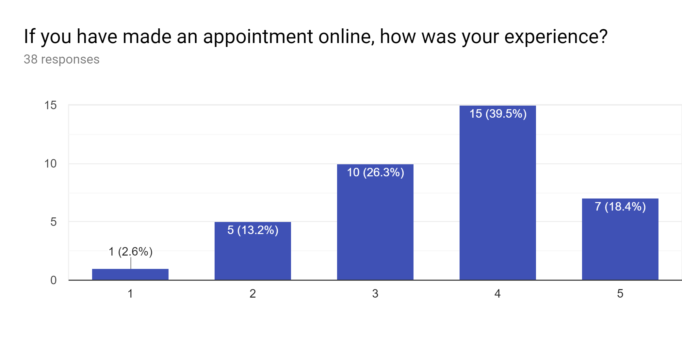

**Illustration:**

* In the given sematic differential scale, 1 stands for terrible and 5 stands for excellent.
* For making online appointments, mostly people (39.5%) have rated their experience a 4 out of 5.
* Also, some people have rated 3 out of 5 (26.3%) and some have rated 5 out of 5 (18.4%).

Hence, the experiences are more inclined towards excellent than terrible.

**17)**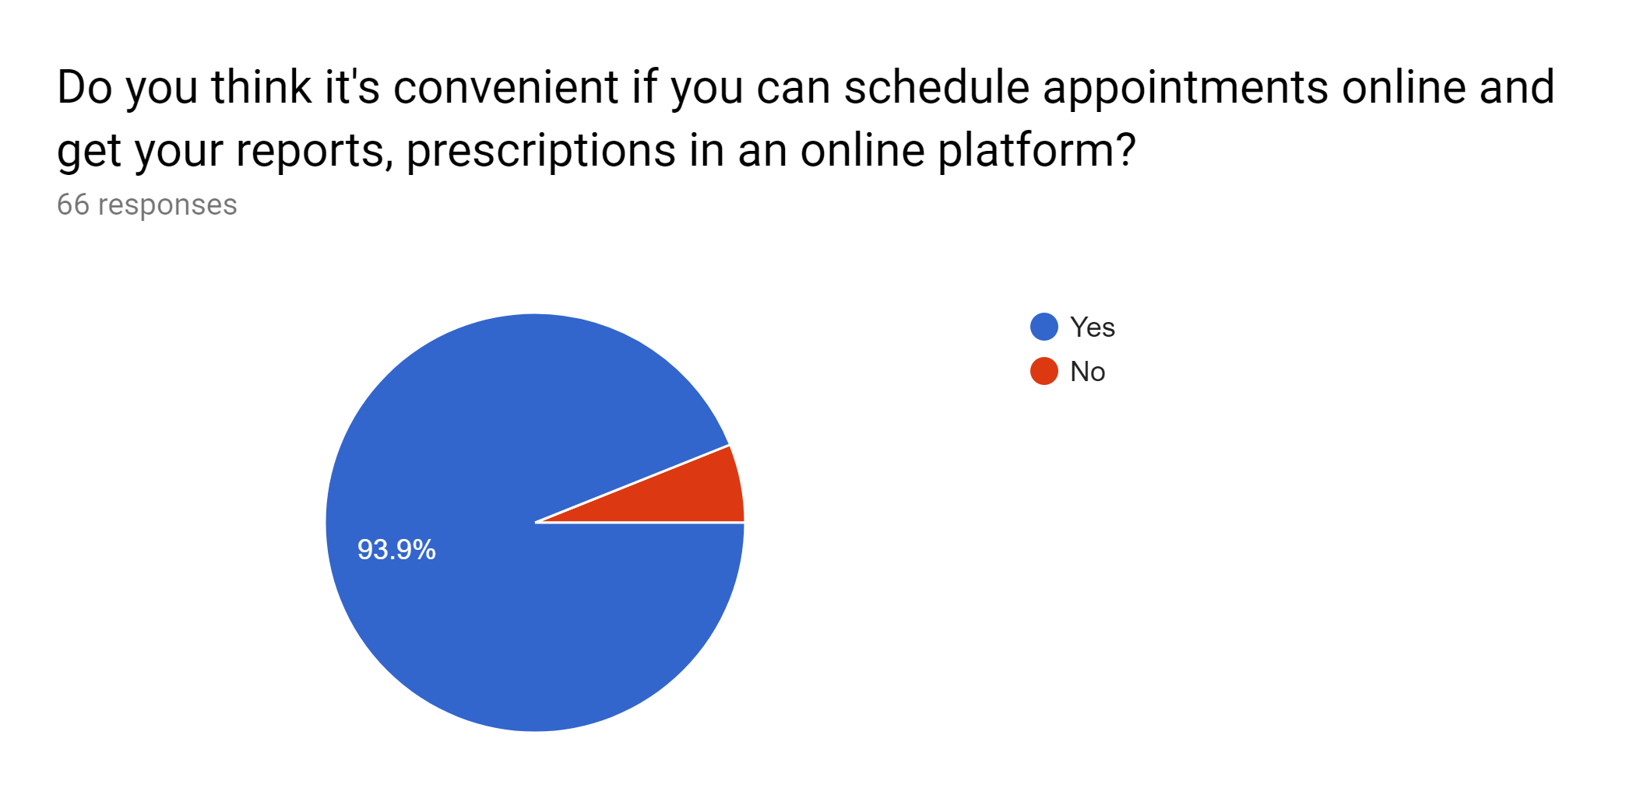

**Illustration:**

* The above diagram depicts that nearly 94% of the respondents feel that it’s convenient to schedule doctor appointment online and get their medical reports and prescriptions in an online platform.
* The rest of the respondents don’t prefer online appointment due to lack of good websites and prefer to schedule their appointment manually.

**18)**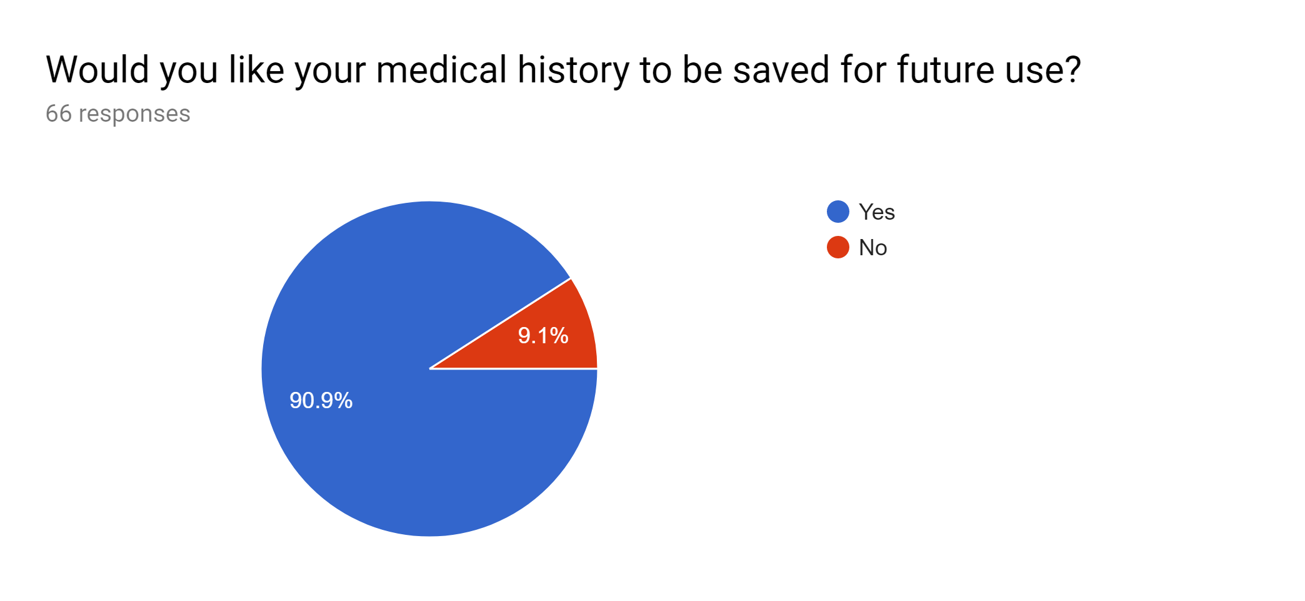

**Illustration:**

* 90.9% people would like their medical history to be saved for future use.
* 9.1% people do not want that since they may have privacy concerns.

**20)**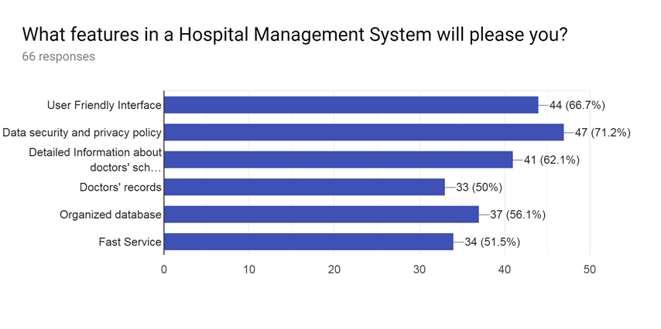

**Illustration:**

* The above diagram illustrates that most of the respondents prefer to have a hospital management system that have excellent security of data at every level of user system interaction, user friendly interface, organized with fast service and have detailed information about doctor’s appointment schedule.
* Some of the respondents also prefer to have doctors’ records saved in the system’s database.

**19)**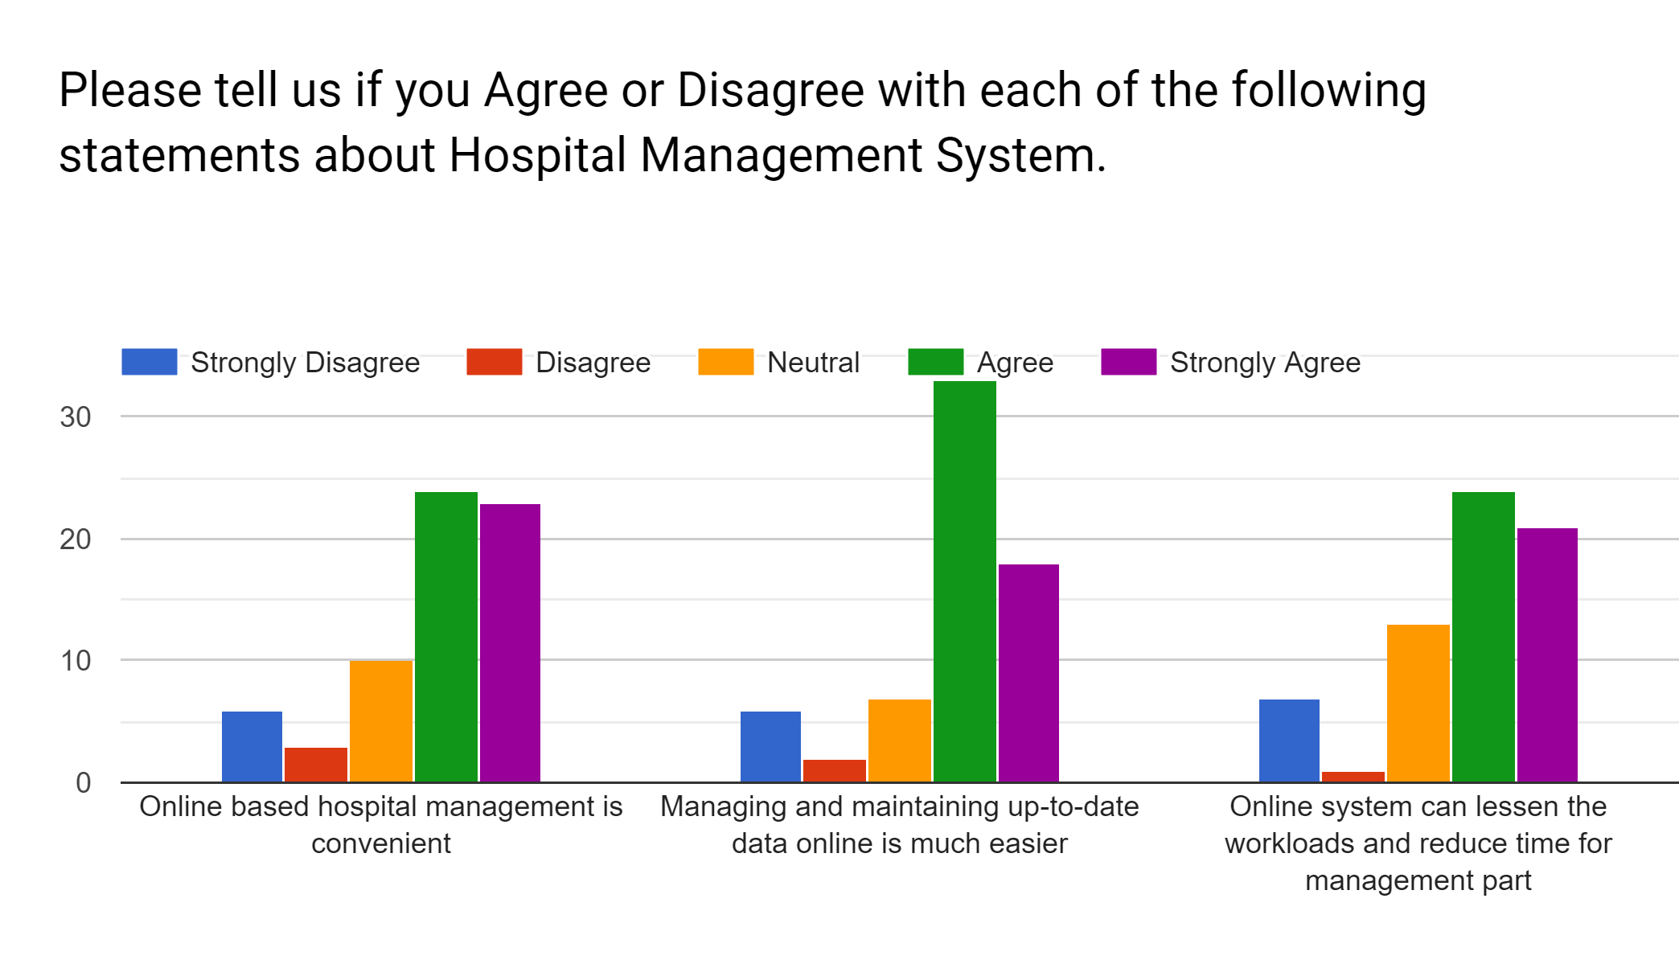

**Illustration:**

* In the above charts, the bar to the extreme right signifies strong agreement and the bar two the extreme left signifies strong disagreement.
* In the first chart, we have majority agreement and strong agreement that online based management is convenient.
* In the second chart, we have majority agreement that managing and maintaining up-to-date data online is much easier.
* In the third chart, we have majority agreement and strong agreement that online system can lessens workloads and reduce time.

**Overall Findings:**

The overall findings from the questionnaire and data analysis is described below:

* The present hospital management systems lack organization. They need to be smoother and more convenient.
* People have difficulties in keeping paper-based reports and prescriptions and would prefer them in digital format.
* Appointment scheduling in hospitals is untimely and an online system would be better for making appointments and maintaining them timely rather than in person or via phone calls.
* Majority of people use internet and people who’ve made appointments online have rated their experience positively.

We must be mindful about the following shared preferences of the respondents and act accordingly:

* Make the website interface user-friendly
* Ensure strong data security and privacy
* Update website contents regularly and provide fast service
* Keep detailed information about doctors and appointment times in the website

**Conclusion:**

The interview and questionnaire process gave us the opportunity to gather views and perspectives of different people and helped us know what users actually want from a hospital management website. After the questionnaire and data analysis, we have revised our design and development scheme for the application. We eagerly look forward to developing a useful, user friendly web application.